Program Development in a Graphical Environment

Efficient Portfolio Frontier

Eliyahu Cano, Sujan Sivakolunthu ,Luyun Chen

Revised on December 3
Program Development in a Graphical Environment
420-203-RE sect. 00003

Nagat Drawel

September 14, 2023

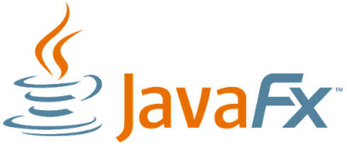

- Task Description
Vocabulary :
- Beta : Ratio defining the sensitivity of a stock to the market. Calculated by dividing the historical return of a stock by the historical return of the market.
- Risk free rate : Fixed payments. Here we take it to be the fed interest rate as it has been one of the highest rates recorded.
- Covariance : Ratio defining the relationship between two securities.

The program
The program will generate an efficient portfolio frontier graph for the selected securities. An efficient frontier rates portfolios on a coordinate plane. Simply by consulting such graph, the user should be able to determine which portfolio composition best suits their investment goal, whether they choose to minimize risk via conservative investments or maximize return via aggressive investments. The efficient portfolio frontier graph has the standard deviation (risk) (%)on its x axis and expected return (%) on the y axis **They are not interdependent. The data points on the graph will represent different portfolios. The portfolioRisk variable of the portfolio object will serve as the x value of the data point, while the portfolioReturn variable of the portfolio will serve as the Y value of the data point.
To calculate the values of the variables for both axes, the program will use a financial insight (TBD) API to obtain the following variables : Risk free rate of the market, The beta of each stock, Expected market return as well as Covariance between the selected stocks. Here’s an example of such graph :
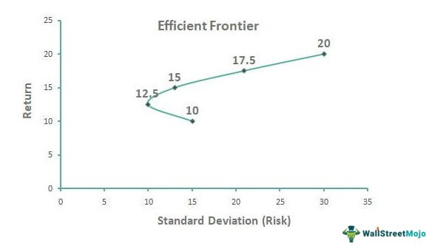
The UI will prompt the user to decide on the following
- Which securities to include in the graph (By search)
- What “points’ must be analyzed (For example, users could select to checkmark the point which will provide the lowest risk. The program will create a dot on the graph for that point and include its risk & return as well as the percentage of each security in order to obtain those stats)

- Interface Visualization
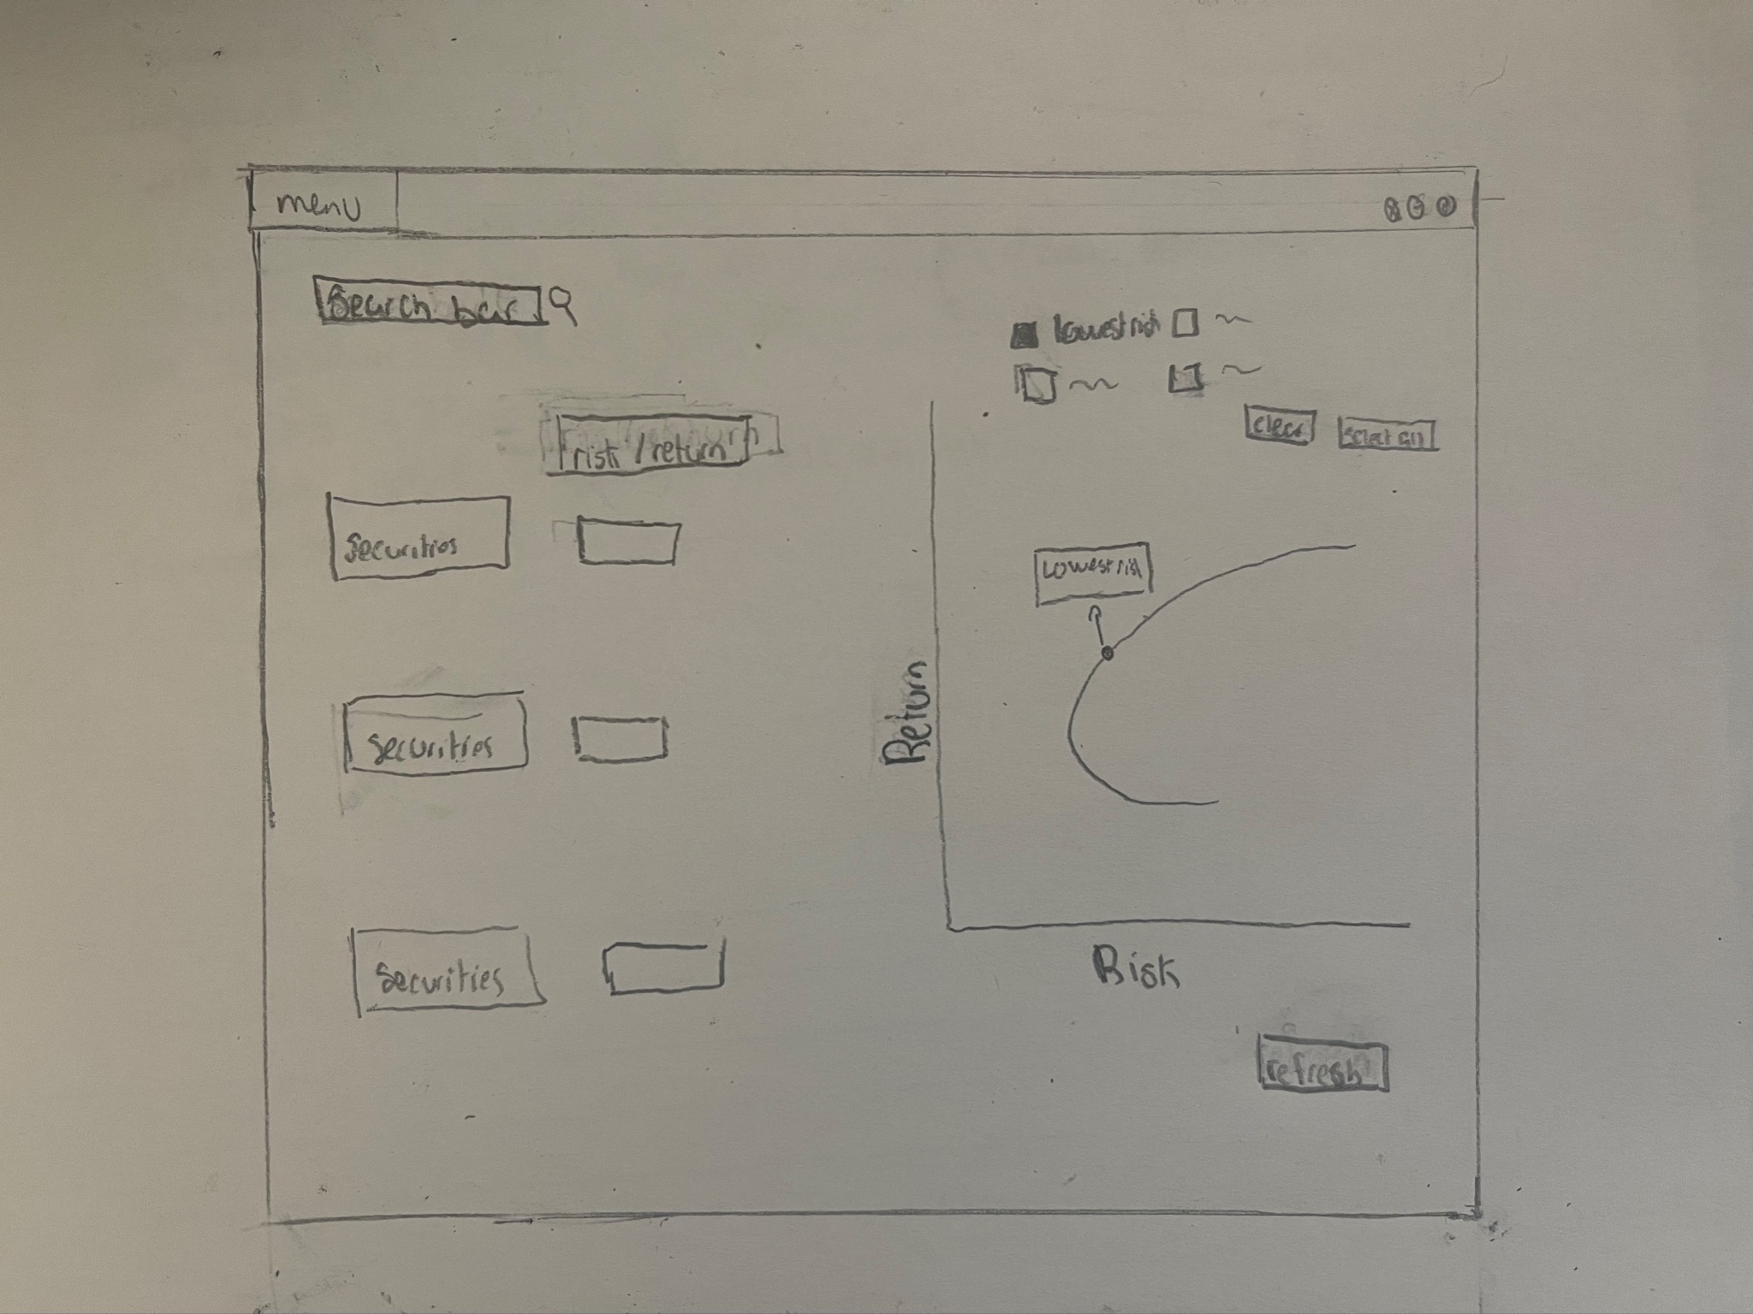

- Proposed implementation approach
The tasks of the program are already broken down in section 2. Here we will briefly discuss the API, math and graph implementations.

3.1 API :
We can implement an API by obtaining its URL -> create the connection -> request the information -> obtain the information
3.2 Math:
The math is quite simple here. If you are familiar with the CAPM model, the math needs not to be explicitly introduced. If not, here is a short summary: We are calculating the weighted expected return by taking the sum of all (weight of security * expected return). The expected return can be found using this formula : 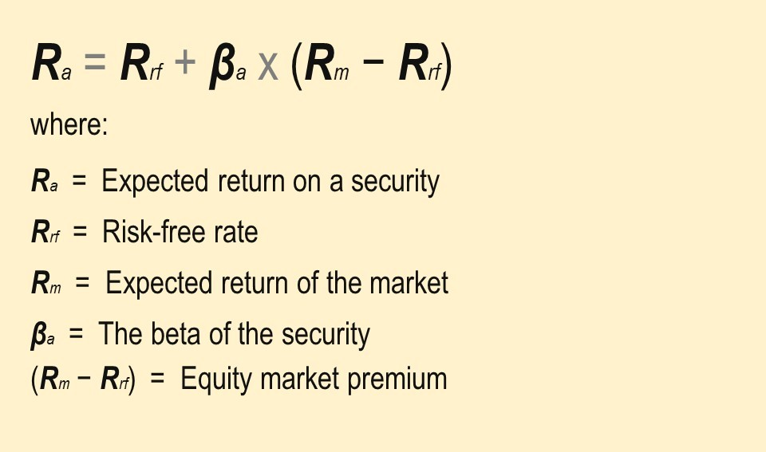
The expected return of the market will be found using historical value AND the risk free rate is just the current federal interest rate.

To find the weighted risk we can follow the following formula :
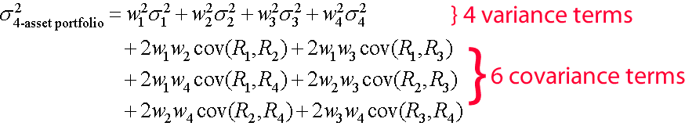
Keep in mind that the amount of covariance terms depends on the amount of assets since we want to know the covariance between each set of two securities.
3.3 Graph :
Imports: Javafx.scen.shape - This import includes a class named QuadCurve which has 6 properties of the type double: startX, startY, controlX, controlY, endX and endY. This will be the start and finish point of the graph as well as the control point. These values will be obtained by the user input. The values will then be set using the quadCurve.set method.
Next, inside of the Start() method we will create a group object. The QuadCurve object will be passed into the the group class as a parameter to the constructor like so: Group root = new Group(QuadCurve).
Next we will create a Scene object and pass the Group root to it.
Next we will set the title to the stage by using: primaryStage.setTitle(“”);
Next we will add the scene to the stage by using primaryStage.setScene();
primaryStage.show(); to display the contents of the scene.

- Task Division & Project management

The task will be divided as following:

Eliyahu will oversee the API and data extraction aspect of the project. Using the API and StockQuote classes he has developed, he will ensure the accurate collection and preservation of data through the StockQuote class. Eliyahu will transform the data into String or double variables suitable for integration into the project. He will adapt the data collection to meet the specific requirements of his teammates throughout the project.
Luyun will manage the project and coordinate collaboration among multiple teammates. This includes instances where Eliyahu's API intersects with Luyun's mathematical work, Eliyahu's API aligns with Sujan's GUI, or Sujan's GUI coincides with Luyun's mathematical calculations. Luyun will be responsible for calculating the risk and return of each individual stock and the portfolio by implementing methods in the StockQuote and Portfolio classes. Luyun will generate the best-fit portfolio based on user input, document the changes made, and create a UML diagram accordingly.
Sujan will create the GUI and link its elements to methods in the FXMLController class. He will extract data from the list of Portfolios and transform it into doubles suitable for use in the graph. Sujan will ensure that each textField, button, listView, etc., has a corresponding event handler and serves its intended purpose. Sujan will also be responsible for creating the test classes.

